R. Reports Menu: B. Comparative Budget Report

Table of Contents
Comparative Budget Report 3
The “General” tab 3
The “Accounts” tab 5
The “Export Options” tab 7

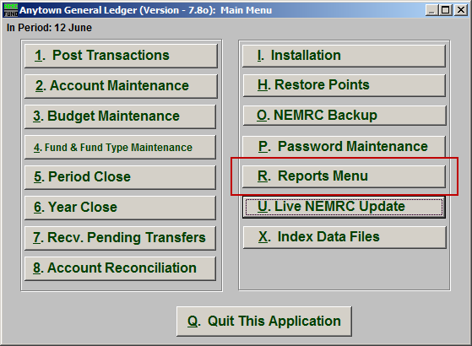
Click on “R. Reports Menu” from the Main Menu and the following window will appear:

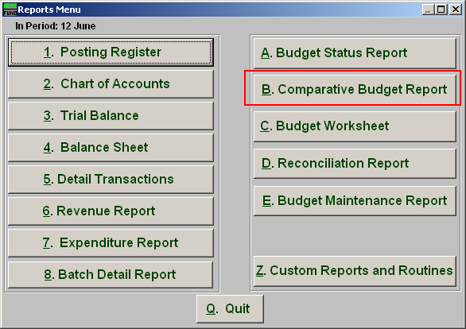
Click on “B. Comparative Budget Report” from the Reports Menu and the following window will appear:

Comparative Budget Report

The “General” tab

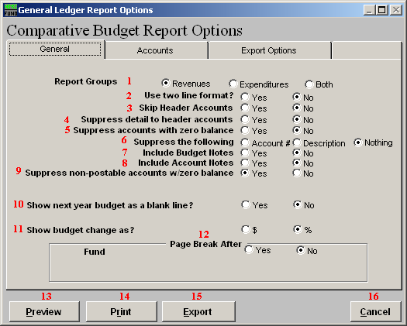
- Report Groups: Select the group of budget accounts to report. Depending on your chart of accounts definition you may not see an option for both.

- Use two line format?: The two line format allows for current year actual or anticipated values to be added to the report by placing the account number on a line above the description and values.

- Skip Header Accounts: Header accounts are defined by incomplete account numbers that the system determines you want all like accounts match what has been defined to sub-total upon. Selecting “Yes” removes the sub-totals.

- Suppress detail to header accounts: Selecting “Yes” will cause the system to report on header accounts defined and all accounts without header accounts defined.

- Suppress accounts with zero balance: You can choose to remove from reporting an account when it has a value of zero in both last year and this year for budget, actual and encumbrance.

- Suppress the following: You can include the current year actual or anticipated balances by suppressing the account number or description if you do not use the two line form.

- Include Budget Notes: Choose “Yes” to have this report include Budget Notes that can be entered during Budget Maintenance.

- Include Account Notes: Choose “Yes” to have this report include Account Notes that can be entered in Account Maintenance.

- Suppress non-postable accounts w/zero balance: You can have the system remove from reporting inactive accounts that have zero like in item 5. This option stops the inactive accounts from reporting. Item 5 would stop all zero balance accounts from reporting.

- Show next year budget as a blank line?: Selecting this option will replace the next year budget from reporting and replace it with an empty line. This can be used in budget preparation.

- Show budget change as: The change in budget can be represented as a percent or dollar value.

- Page Break After: Click to choose when a new page is started. The option for page breaks depends on the design for your chart of accounts.

- Preview: Click this button to preview. Refer to GENERAL PREVIEW for more information.

- Print: Click this button to print. Refer to GENERAL PRINTING for more information.

- Export: Click this button to save on this computer. Refer to GENERAL FILE for more information.

- Cancel: Click “Cancel” to cancel and return to the previous screen.

The “Accounts” tab

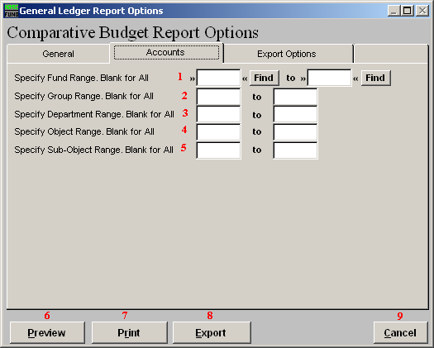

- Specify Fund Range: This option appears for all charts of accounts. Type in a beginning and ending fund number range to further restrict the reporting if desired. Items 2 through 5 will vary according to the design and descriptions for your chart of accounts definitions.

- Specify Group Range: Enter a beginning and ending value range to further restrict the reporting if desired.

- Specify Department Range: Enter a beginning and ending value range to further restrict the reporting if desired.

- Specify Object Range: Enter a beginning and ending value range to further restrict the reporting if desired.

- Specify Sub-Object Range: Enter a beginning and ending value range to further restrict the reporting if desired.

- Preview: Click this button to preview. Refer to GENERAL PREVIEW for more information.

- Print: Click this button to print. Refer to GENERAL PRINTING for more information.

- Export: Click this button to save on this computer. Refer to GENERAL FILE for more information.

- Cancel: Click “Cancel” to cancel and return to the previous screen.

The “Export Options” tab

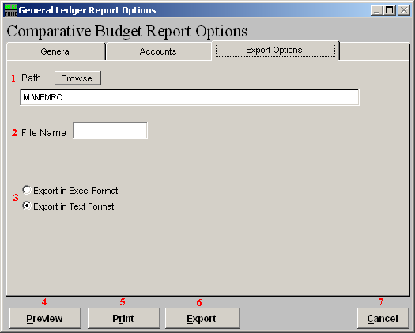
- Path: Type in the location of the folder you wish to save this report in when you export. You may click “Browse” to locate the folder.

- File Name: Type in the name that this report will be saved as.

- Export in Excel OR Text Format: Click to choose whether this report will be exported in an Excel Format or in a Text Format.

- Preview: Click this button to preview. Refer to GENERAL PREVIEW for more information.

- Print: Click this button to print. Refer to GENERAL PRINTING for more information.

- Export: Click this button to save on this computer. Refer to GENERAL FILE for more information.

- Cancel: Click “Cancel” to cancel and return to the previous screen.

